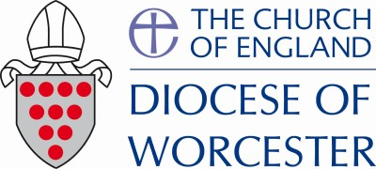
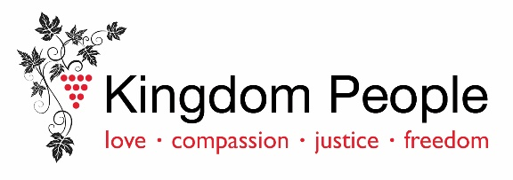

Healthier Churches Fund: Application Form Notes
Please read these notes carefully before completing the form.
1. This form can be used for applications for support from the Healthier Churches Fund as well as for parishes applying for Lowest Income Communities Project Funding, or from other trust funds including the Kingdom People Fund. The Diocesan team will allocate grants as appropriate from the different funds to ensure the greatest possible benefit can be achieved from the funds available.
2. We strongly encourage you to get in touch early to discuss your emerging thoughts. If you have the support of a Mission Accompanier, they are ready and willing to assist you in shaping your thinking and proposal. For further guidance and assistance in formulating your proposal, you can contact Damian Herbert (dherbert@cofe-worcester.org.uk), Andy Todd (atodd@cofe-worcester.org.uk), or Nikki Groarke, who serves as the Diocesan Leader for Transformation and Change
(ngroarke@cofe-worcester.org.uk). They are available to provide expertise and support in refining your plans.
3. Applications can come from a single church (with the approval of the PCC), from a benefice, a group of churches, a deanery or wider. Collaboration is, in general, a good thing.
4. We anticipate that most applications from a single church will be below £10,000, but that some, especially from Lowest Income Community parishes and where there is a strong missional proposal can be larger. We expect that most applications over £50,000 will have an impact in more than one parish. It is essential that applications demonstrate a realistic impact for the size of funding sought, and a good return on the investment sought.
5. We want clarity of thinking rather than lots of detail – essentially you need to be clear as to what you will do, what impact you hope it will have, how much you expect it to cost, and how this proposal fits with your overall priorities. We don’t expect most forms to be longer than two sides of A4 plus any attachments.
6. The form asks for a Health and Sustainability plan to be attached. This does not need to be complicated but should demonstrate that your proposal is integral to your plans for increasing health and sustainability and is one of your top priorities. A template, along with some examples, can be found on the diocesan website.
7. When completed the form should be sent to the Diocesan Secretary, Andy Todd at
atodd@cofe-worcester.org.uk

Healthier Churches Fund: Application Form

- CONTACT:
Name of person making the application:
Email:

Phone:

Parish / Benefice:

Name of Incumbent (if different from name above):

- OVERVIEW:
Please summarise your proposal – What do you want to do? What are the aims and objectives?

Please attach your Health and Sustainability Plan. Please can you explain briefly how this proposal supports your Health and Sustainability plan.

- IMPACT:
What outcomes do you hope, with God’s grace, to see from the project? (These should be specific, measured where possible, and have a timeframe). Please list up to three.

- SUMMARY OF COSTINGS:
Please summarise the anticipated overall cost of your initiative, broken down into major elements. If any costs relate to employment of resource, please break that out separately. (If funding will be used to fund or part-fund an employed resource, please attach the proposed job description).
What contribution, if any, is the PCC planning on making? (Note: We would then follow up with the parish if this raised questions, or if they had not provided us with their accounts.)
For projects seeking more than £50k, please can you breakdown the expected grant drawdown by year.

- GOVERNANCE (medium/large projects only)
Who will have oversight of the initiative and be accountable for its delivery?

- DELIVERY PLAN
Please can you provide us with an outline of the delivery plan – (what, when, who for the key tasks)?

- POST GRANT SUSTAINABILITY
If successful in being awarded a grant and in carrying out your project, how will your objectives be sustained post-project?

- BACKGROUND AND GOOD PRACTICE:
What is the approximate population of the parish(es) / benefice(s) that is (are) making the application? (If the application is from a group please include each parish individually).

Please state your current and previous year’s Ministry Share request and the percentage that was paid during each year.

- Current year’s Ministry Share
Percentage Paid

- Previous year’s Ministry Share
Percentage Paid

Is your church’s health and sustainability plan attached? Y / N

Are you making active use of the Parish Giving Scheme? Y / N

